**Assignment No-6**

**Table Data:-**

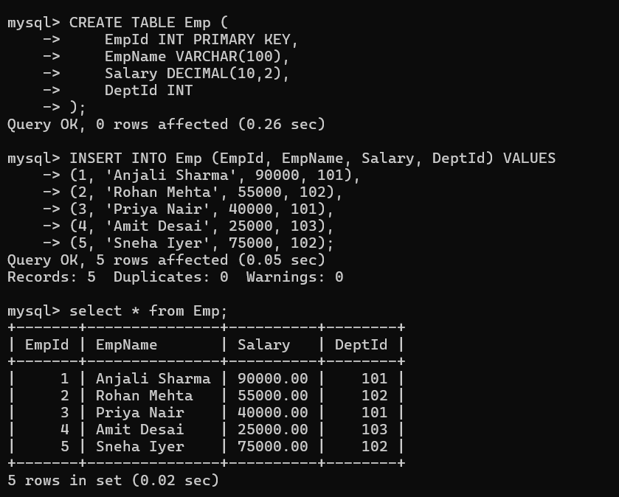

--------------------------------------------------------------------------------------------

1. Write a SQL query to **create a stored procedure without any parameters** that displays all employees from the Emp table.

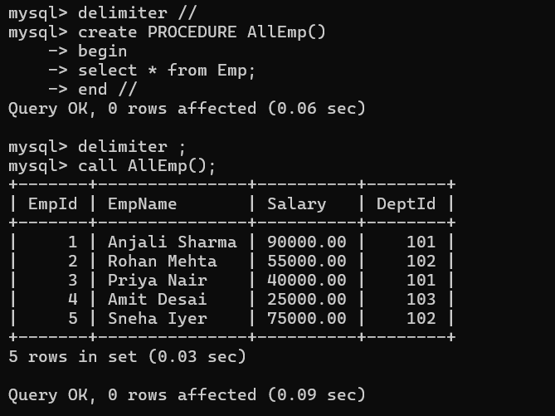

------------------------------------------------------------------------------------

1. Write a SQL query to **create a stored procedure with an IN parameter** that accepts a department ID and displays all employees belonging to that department.

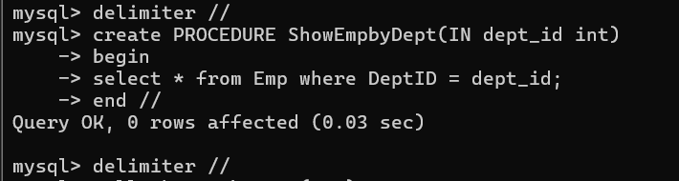 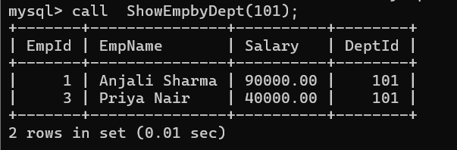

---------------------------------------------------------------------------------

1. Write a SQL query to **create a stored procedure with an OUT parameter** that returns the total number of employees in the Emp table.

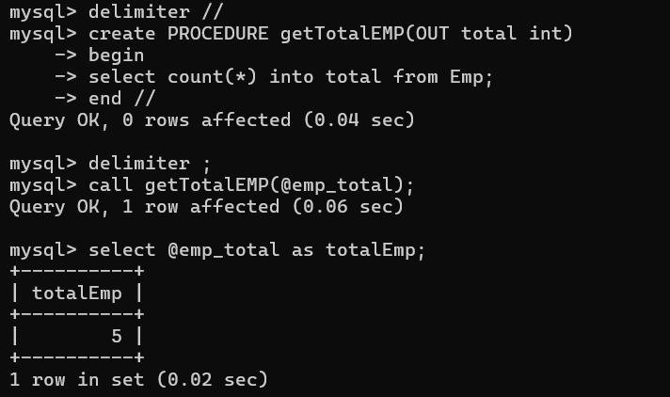

---------------------------------------------------------------------------------

1. **Write a SQL function that accepts an employee’s salary as input and returns a grade based on the following conditions:**

If salary ≥ 80,000 → Grade = 'A'

If salary ≥ 50,000 and < 80,000 → Grade = 'B'

If salary ≥ 30,000 and < 50,000 → Grade = 'C'

Otherwise → Grade = 'D'

Use appropriate **IF / IF-ELSE / CASE statements** inside the function to implement this logic.

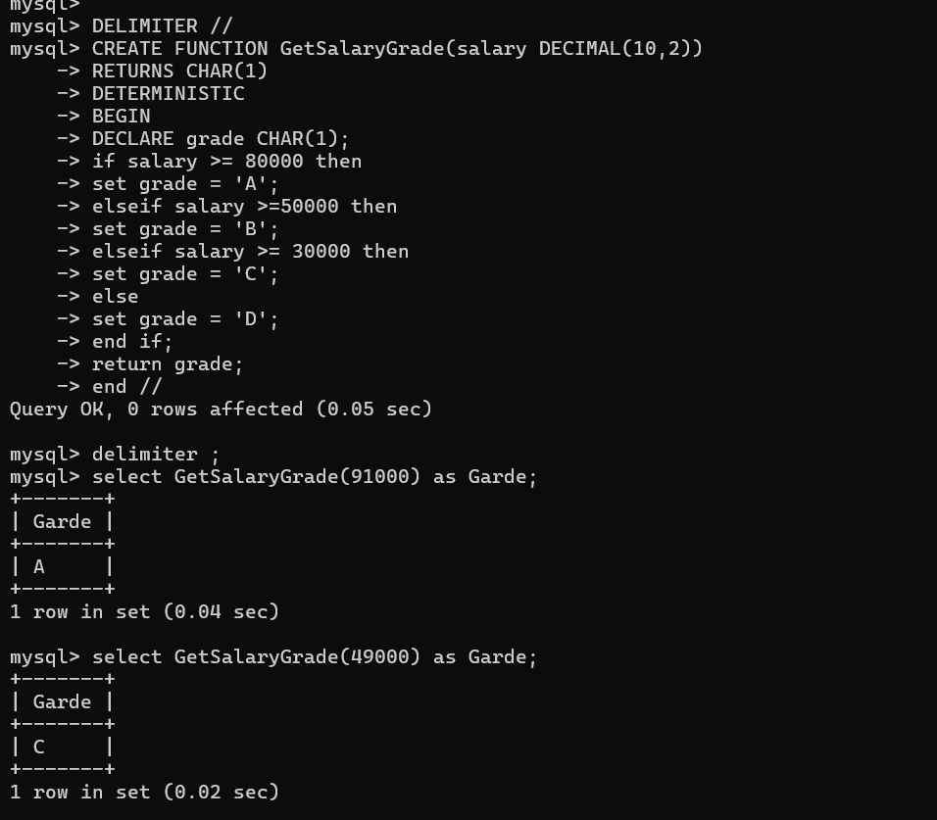

---------------------------------------------------------------------------------

1. Write a stored procedure that uses an **explicit cursor** to fetch and display the details of all employees whose salary is greater than 60,000 from the Emp table. Make sure to DECLARE, OPEN, FETCH, and CLOSE the cursor properly.

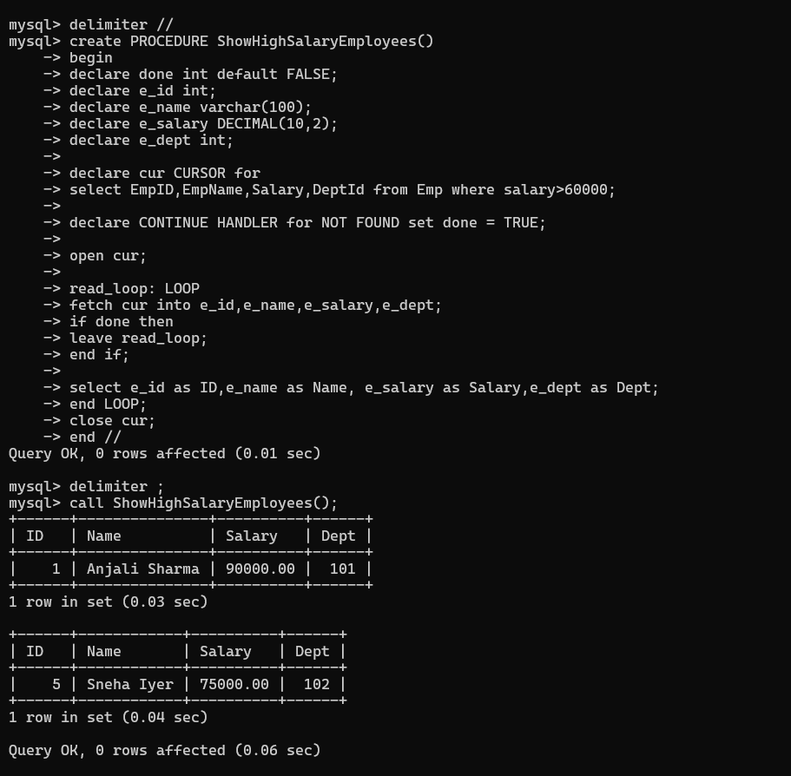

------------------------------------------------------------------------------------

1. Write a trigger on the Emp table that checks before inserting a new employee record:

If the Salary is less than 10,000, prevent the insertion and raise an error message "Salary too low".

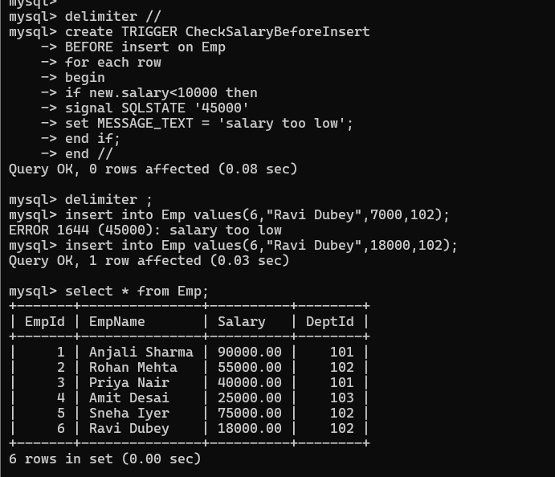

---------------------------------------------------------------------------------

1. Write a stored procedure in SQL to **print numbers from 1 to 10** using a **WHILE loop**.

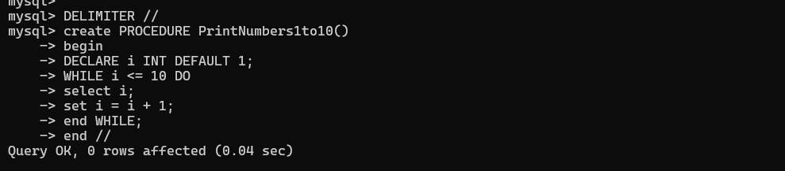

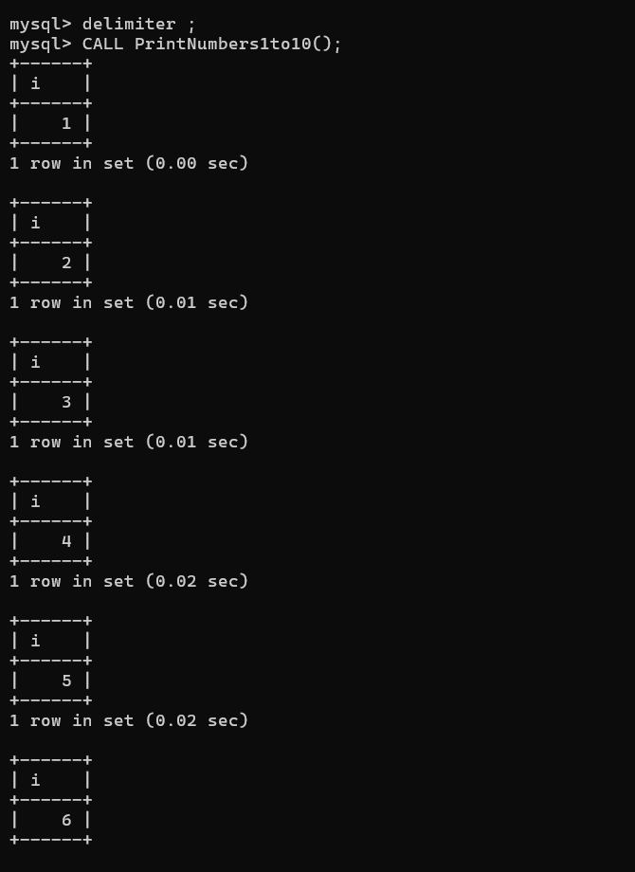

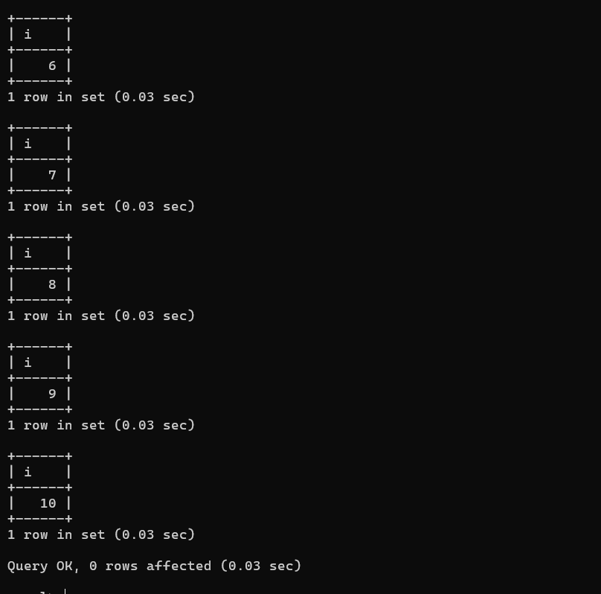

---------------------------------------------------------------------------------

1. Write a stored procedure to print the multiplication table of 2 using a loop

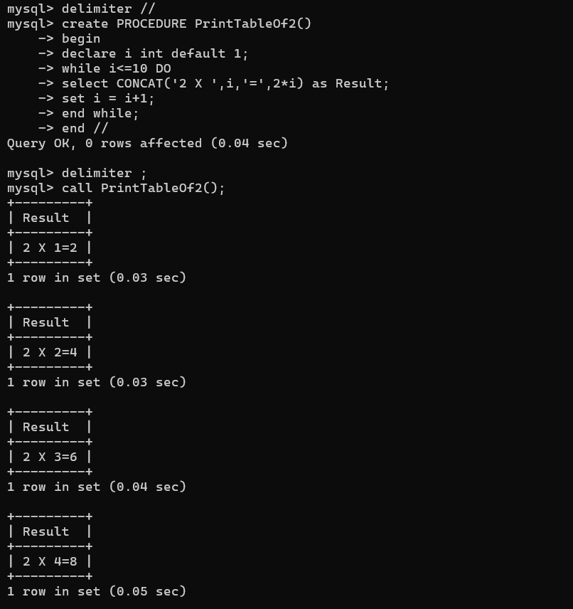

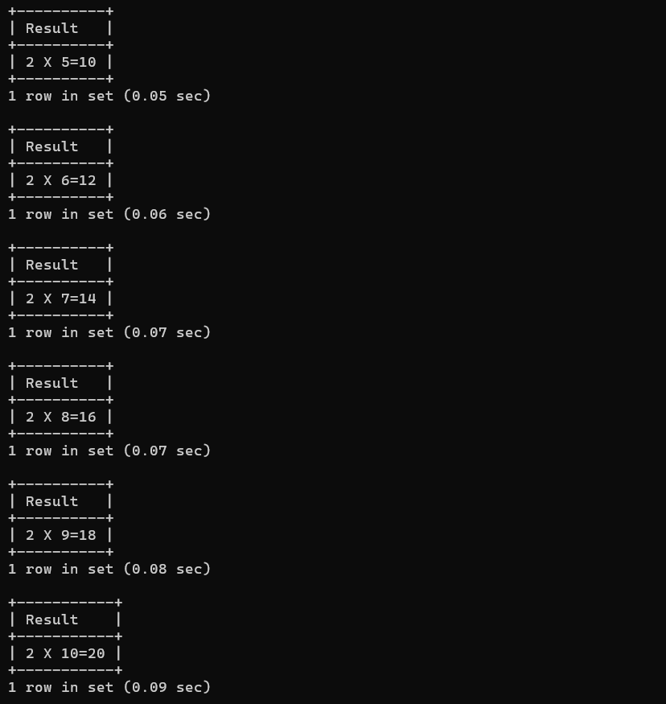

---------------------------------------------------------------------------------

1. Write a  **function to check whether a number is even or odd.**

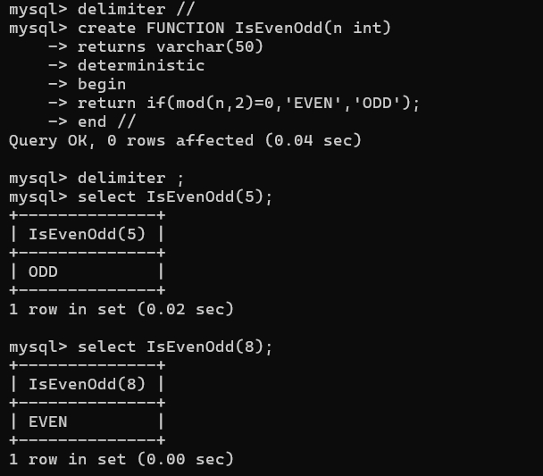

---------------------------------------------------------------------------------

1. **Write a user-defined function to calculate the factorial of a given number.**



